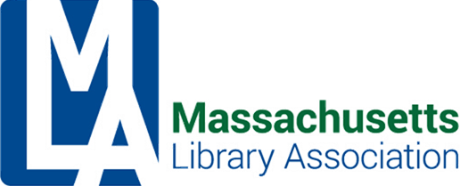

Administrative Board Meeting
November 8, 2017
Conference Call
1:00 PM
MINUTES
Attending: Alex Lent, Will Adamczyk, Nanci Milone Hill, Jennifer Pike, Nora Blake, Jennifer Zolkos

1. Call to order – 1:04pm

2. Treasurer’s Report – Numbers are consistent for October. The balance in the checking account is low. A transfer from cash reserves needs to be made so we can cover expenses.

Acceptance of Treasurer’s Report – Will moved, Nanci seconded, all approved.

3. President’s Report
- Can we increase allotment for ALA Councilor?
- ByLaws changes need to be finalized and presented to the Executive Board at the February 2018 meeting.

4. Vice President’s Report
- Will is working with Bernadette Rivard and Deb Abraham to develop finance procedures for MLA. They are discussing changing the committee from an Investment Committee to a Finance Committee to broaden the scope of work that the committee performs and to add more members to the committee.
- They are also working to update the signatories on the investment accounts.
- If we want to make a change to membership fees and levels, the December Executive Board meeting should discuss and approve so it can be moved out to membership in time for their review and vote.

5. Executive Manager:
Jennifer Zolkos is working with Kristen Colliins on conference vendor material which will be mailed out soon.
She is updating website pages for various sections and committee. MLA would benefit from a different template for the website. Can a committee be formed to review this and choose something else? What about the tech services technology committee?

6. Adjourn – Meeting adjourned at 1:36pm

