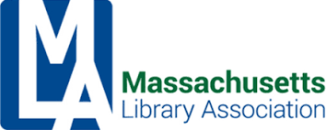

**President’s** **Executive Board Report — October 2022**

**Meetings attended:**

* MLS/MBLC/MLA Meeting on August 16, virtual, to discuss the ways the three organizations are prepared to help with challenges across the state.
* MBLC Board Meeting on September 1 at the Worcester Public Library.
* MLA Admin Board Meeting on September 9, virtual.
* NELA State Association Presidents' meeting on Tuesday, September 27th. Several other state associations are dealing with challenge issues (related to programming and materials) in serious ways.
* Minuteman Meeting with MLS and MBLC and the co-chairs of IFSRC to discuss what we can do to help libraries prepare for and deal with challenges. She will be joining them again on October 19 in Wareham at SAILS. IFSRC co-chairs have been attending several other Network Director’s meetings to impress upon Directors the need to train front-line staff in how to handle it when a patron wants to challenge something.

**Upcoming Events:**

* Kim Hewitt will be attending the Oct 22 NELA Legal Issues Seminar, and Conference Oct 23-25. There is a Chapter Leaders Forum on Sunday, Oct 23, at 3:15 if anyone will be there or has anything they would like me to highlight.
* MLA Digital Privacy discussion on November 3 at 11am!!! Help spread the word!
* MLS Annual Meeting on November 7, in Devens.
* MLS/MBLC/MLA will meet again to check in on November 15, virtually.

**Personnel/Chair Updates:**

* Emelia Thibeault is no longer serving on MLA’s eBoard as she has resigned from the Personnel Co-Chair position.
* Danielle Savin is interested in getting involved with MLA again at a co-chair level. We would be very happy to have Danielle back!
* Aimee Westphal is wrapping up two MLA projects and will then be resigning from her post as MLA archivist. If you know of interested parties, please let the Admin Board know!

**Website Development:**

* Krista and Emelia were working on a way to get information from section and committee chairs re: needs for a new site. A question was raised about whether re-branding should be included in this project.

Respectfully submitted,

Kim Hewitt, President

October 11, 2022



**Library Information Technologies Section (LITS)**

**Executive Board Report — October 2022**

MLA’s Library Information Technologies Section (LITS) is making progress on two main fronts: rebuilding its internal processes and engaging its community around topics related to its scope. LITS is making progress on revising its By-laws and will be re-evaluating roles, term limits, and how decisions are made. Secondly, LITS has been working on its Conference responsibilities, and LITS is grateful to Chris Kaufman who has agreed to join Jeremy Goldstein and liaise MLA’s Conference Committee as part of their roles as LITS Members at Large. Additionally, LITS is moving forward with offering Digital Safety Training for Library Workers, as [hostility](https://www.theguardian.com/books/2022/sep/20/librarians-banned-books-attacks-library) towards library workers [continues to gain momentum](https://www.ala.org/advocacy/letter-concern-fbi-regarding-threats-violence-libraries). Under Chris Kaufman’s initiative, MLA LITS is exploring ways to connect LITS with the [New England ASIST Chapter](https://www.asist.org/chapters/neasist/) to increase networking and engagement opportunities for LITS members. This is really exciting, and it is our hope that this will be of value to LITS and the library community.

**Past Activities:**

* August 11: LITS Chair met with MLA President and Vice President to discuss Digital Safety Training options; discussed possibilities.
* September 15: LITS held a meeting by Zoom from 2:00 to 3:00 PM. Topics covered included whether to move forward with Digital Safety programming; outreach opportunities for LITS; Conference needs.

**Upcoming and Ongoing Activities:**

* October 27 from 2:00 to 3:00: LITS Meeting to discuss Conference and other internal matters is scheduled. Meeting is open to LITS Members.
* November 3 from 11:00 to 12:00: Digital Safety Training for Library Workers is scheduled and is open to MLA & MA Library Community. Follow-up event has been tentatively scheduled for December 8. Registration is open on MLA’s Calendar of Events for the November date.
* LITS By-Law revision process is underway. Deadline for initial feedback from LITS Membership is October 15.
* LITS is exploring the possibility of coordinating with IFSRC on a conference program focused on Digital Safety.

Respectfully submitted,

Andrea Puglisi, LITS Chair

October 5, 2022



**MLA Legislative Committee Report**

**October 2022**

Legislative Committee held its first meeting of the new cycle on September 23, 2022.

We are continuing to meet via Zoom, but hope to have quarterly in person meetings as well. We had many members in attendance, representing most parts of the state, as well as several different key partner organizations. The group has been meeting at least monthly, with some subcommittee meetings working in between. There are some new faces this year, which is also great.

The Legislative Committee has identified the following as the focus of the group for the year (in no particular order):

* MBLC Legislative Agenda – the committee will continue to work with the MBLC and other partners to advocate for the adoption of the Legislative Agenda. Both Eileen and Will attended the MBLC board meeting where it was discussed. The committee will work with Mary Rose Quinn to coordinate calls to action at the appropriate times during the budget cycle.
* eBook Legislation – the committee will continue to work with Rep. Ruth Balser and her team to get a new and improved eBook bill introduced in MA. We will work with our stakeholders and try to draft new legislators to the cause. The committee also continues to monitor what is happening in other states and on the federal level.
* Increased Advocacy Efforts & Coalition Building – the committee will work to be involved in a wider array of legislation, focused not just on libraries, but on things that may affect library workers and library users. We will work the EveryLibrary to identify legislation that will build partnerships and increase MLA’s advocacy efforts.
* Legislative Day/Legislative Breakfasts – the committee is prepared to offer both an in person return to the State House and virtual legislative days in 2023. We have formed a subcommittee to begin this work. In addition, we are committed to assisting libraries, networks, etc. that are interested in hosting their own local events.
* Respond to/Prepare for increased challenges to libraries & library workers – the committee will work with IF/SRC to address the growing challenges faced by libraries. While IF/SRC can focus on the response to incidents and help libraries be prepared, LegComm will begin to work with legislators and other experts to investigate legal and legislative actions that may be appropriate.

All of this was discussed at our first meeting. We have set a number of committees and will continue much of the work using a committee structure.

Also, LegComm continues to benefit from working with members of MBLC, MLS, MSLA, WMLA, and CMLA, who regularly attend our meetings. Next meeting: October 28, 2022

Respectfully submitted,

Co-Chair, Eileen Dyer, Swansea Free Library & Co-Chair, William Adamczyk, Milton Public Library



**MLA Program Planners Section Report**

**Friday, September 9, 2022**

1. We have been meeting through the summer to create a WordPress site to start collecting

data for a statewide database. Robin Brenner created a sub-domain on her own website

and we worked on the structure of the site. We were hoping to share the form with

members of our group, but the MLA EB would prefer to discuss how we can make this a

part of either the current MLA site or the eventual one.

a. With that question, I sent a report to the President of MLA to share our concerns

of the current site and why we recommend moving the entire site to WordPress

b. Kim said they have created a website discussion committee and will take our

thoughts into account

2. Student Liaisons

a. Darshana Merchant and Ruby Vail have been working all summer on creating

documents and a structure for our Student Liaison program and will be reaching

out to LIS schools (URI and Simmons) to see if we can encourage a couple of

students to join MLA and our section

b. Through our fundraising efforts, we can host two students, paying for their MLA

student membership and for their registration to conference. If we raise more, we

may consider paying for their hotel/meals

3. Library Programming Best Practices

a. Our Program Planners Warriors group has also been hard at work this summer and

have created an amazing spreadsheet of programming best practices

b. We wanted to create a free WordPress website to populate the information on the

spreadsheet but the MLA board asked us to hold off on this as they discuss their

website options

c. Instead of creating a website, at this time, the group decided to create a Google

Slideshow to share the most relevant information. A link can be put on the PPS

webpage and should be a great placeholder until we have a better idea of where

the website will go

4. Our Sub Committees are all working on program proposals for MLA annual conference.

5. We are working on a standalone conference for Oct 2023

a. In the meantime, we’re going to do monthly virtual showcases to have

performers/speakers make themselves available to discuss what they offer. Robert

Hayes has taken the lead on the adult one, planned for January 2023, Robin

Brenner will lead on a Feb 2023 one for Teens.

b. We are looking for a Children’s Chair or a liaison for the YSS committee. We hope that person will help us create a virtual showcase for children’s librarians.

6. Our next open meeting will be Tuesday, September 20, 2022 at 3:00 PM.

Respectfully submitted:

Meena Jain

Chair



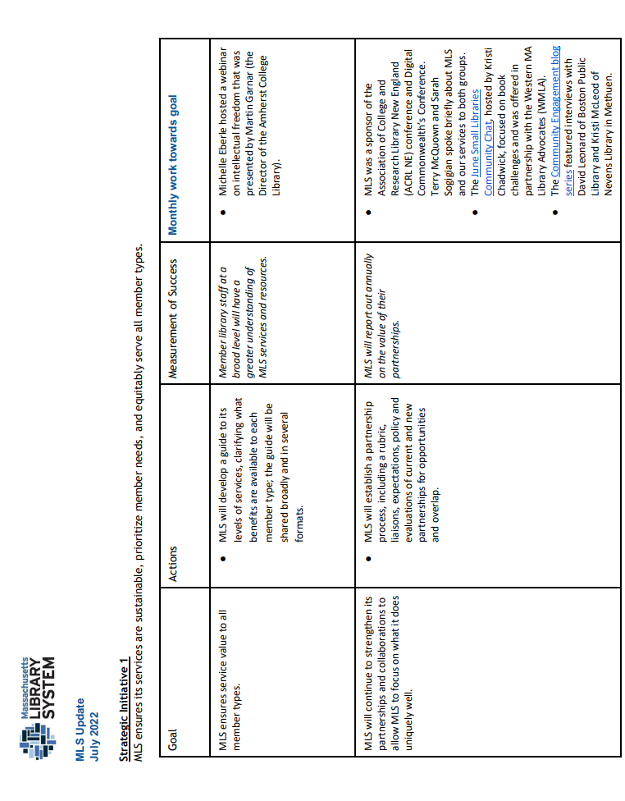

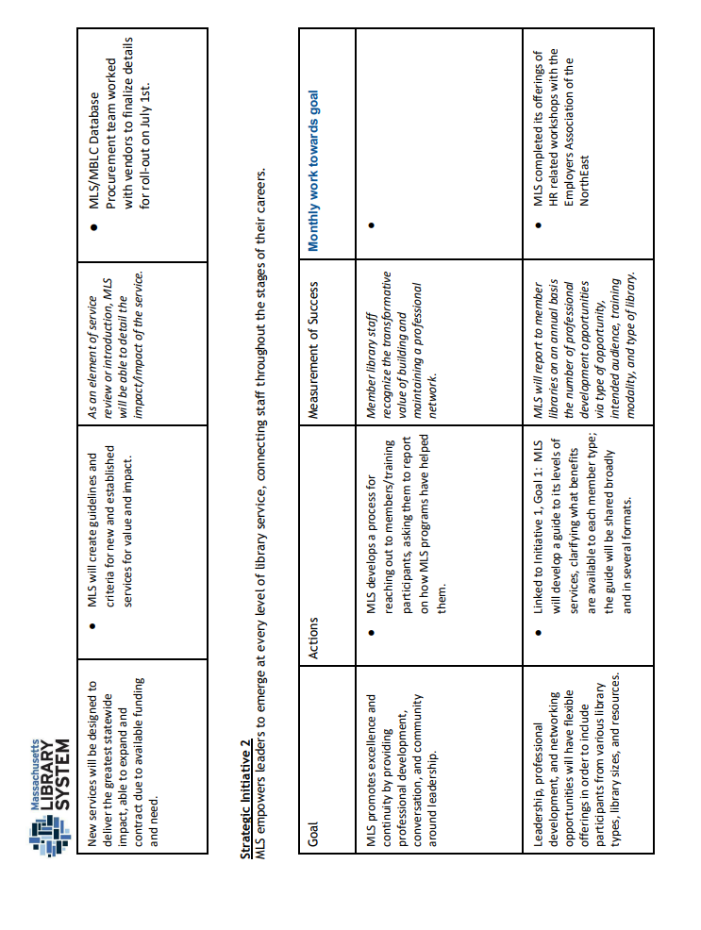

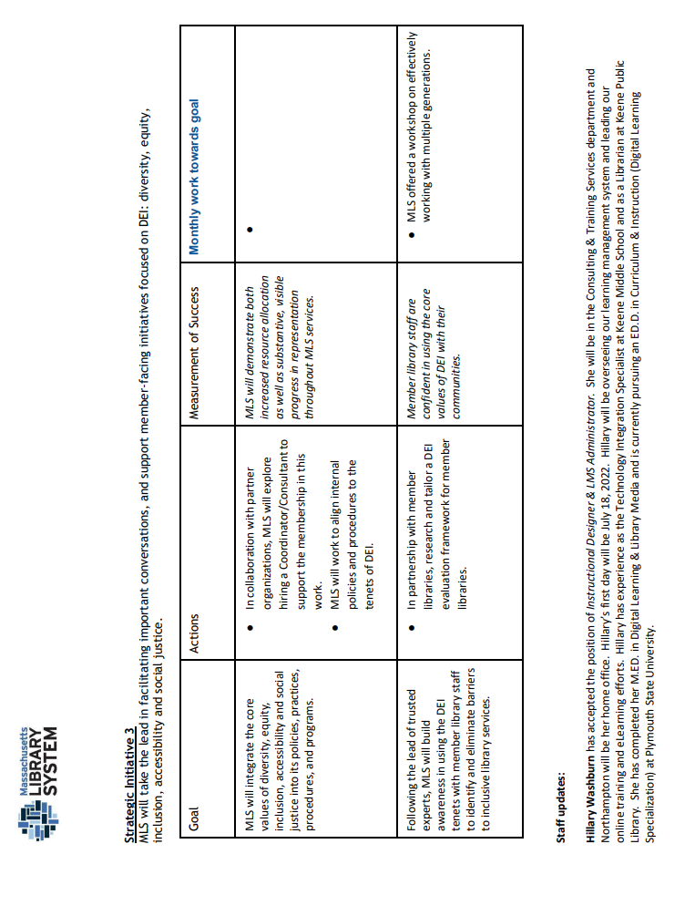



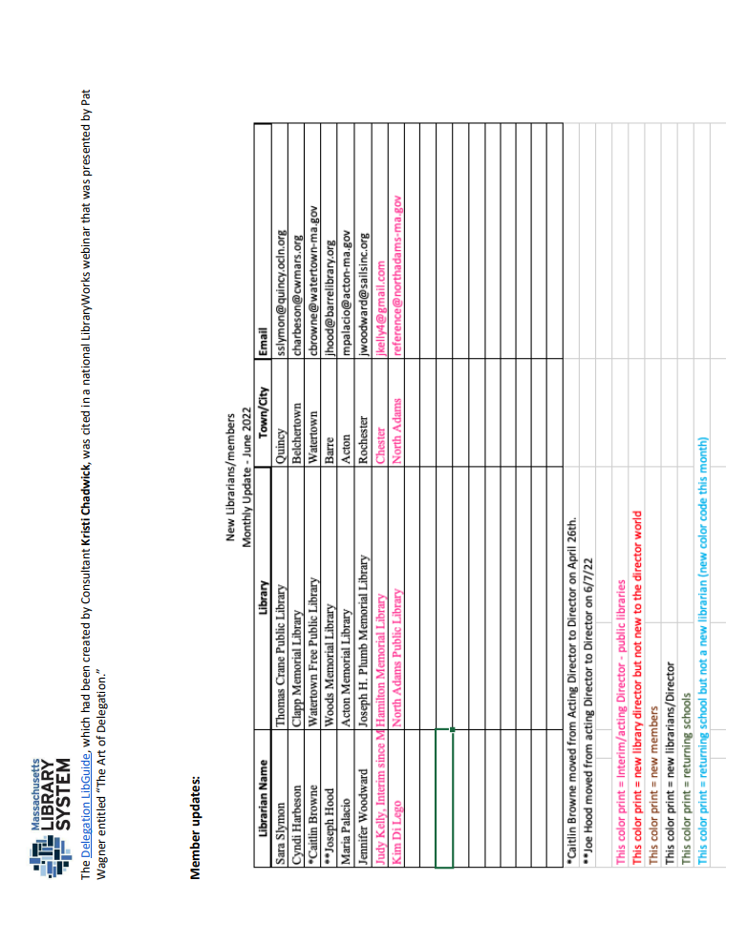



**MBLC Director’s Report to MLA Executive Board**

**October 2022**

**FY2024 Legislative Agenda**: The Board of Library Commissioners voted to approve the FY2024 Legislative Agenda budget request at its monthly meeting on September 1. MBLC affiliates, partners, and Massachusetts library organizations were invited to provide input on the proposed legislative agenda at the meeting. Thank you to Kim, Will, and Eileen for representing MLA and participating in the meeting.

We are focusing on three funding priorities for FY2024: Library Technology and Resource Sharing (7000-9506) and the Perkins and Worcester Talking Book libraries. We are requesting 30% increases for those three budget lines and 10% increases for our other budget lines.



**New LSTA Five-Year Plan**: IMLS has officially approved our new LSTA Five-Year Plan 2023-2027 and it has been posted to our website at: <https://mblc.state.ma.us/programs-and-support/lsta-grants/lsta-plan.php>

With the end of federal fiscal year 2022 on 9/30/22, the active phase of the **MBLC hotspot program** is now over. Paul Kissman sent a survey to the over 200 public libraries that have been circulating over 3,000 hotspots to gather circulation statistics as well as general information on program performance as well as each library’s future plans for lending hotspots. We are also asking for stories about the hotspot lending program that we can share with IMLS.

**MPLCP Legislative Meeting**: Senator Comerford and Rep Domb requested a meeting to discuss library building projects and “spiking construction costs.” Chair Conrad, Mary Rose Quinn, Lauren Stara, Andrea Bono-Bunker, and I met virtually on September 21 with legislators and/or staffers from twelve municipalities (Amherst, Brewster, Deerfield, Fitchburg, Gloucester, Lynnfield, Orange, Seekonk, Sharon, Swansea, Westborough, and Westford--please note that seven of these municipalities—Amherst, Deerfield, Gloucester, Orange, Seekonk, Westborough, and Westford--plus Grafton signed on to letters recently submitted to the Governor and to leadership in the House and Senate requesting state ARPA funding).

After legislators discussed the community impact of increased construction costs, MBLC staff provided information about how our MPLCP awards are calculated and explained the limits on any changes to our MPLCP awards (current regulations do not allow us to increase our awards and we are limited by our annual cap and our bond authorizations). Senator Tarr suggested that his legislative colleagues investigate the possibility of “pothole” funding for these increased costs, either from ARPA or other state funds that would be separate from MPLCP funds, given the limits on our funding. Andrea and Lauren offered to update the estimated costs that the twelve communities have been using to determine their additional funding request, which is listed as $87.6 million as of 10/4/22: <https://act.newmode.net/action/massachusetts-taxpayers-library-construction/take-action-massachusetts-libraries>. They followed up with a detailed spreadsheet on Friday, 9/30 that included three additional projects: Marlborough, Greenfield, and Melrose.

**Intellectual Freedom Response**: MBLC’s outreach efforts to the library community regarding intellectual freedom and materials challenges continue. Representatives from the MBLC, MLS, and MLA have reviewed outreach efforts and gotten attendee feedback at Network Membership meetings for CW MARS, Minuteman, and CLAMS, and are scheduled to speak at SAILS, NOBLE, OCLN, and possibly MVLC in the coming weeks. Maura Deedy has been speaking on behalf of the MBLC and has been joined by Andrea Fiorillo, the co-chair of MLA’s Intellectual Freedom Committee, and Sarah Sogigian from MLS.

**Shelley Quezada** is working with the Framingham Public Library (Christa McAuliffe branch) in partnership with the [*STAR Library Network*](https://urldefense.com/v3/__https:/www.starnetlibraries.org/__;!!CUhgQOZqV7M!kth2R0qb2JNYXKgoGXGsPTJPh7F_KYRoU1Y2pf-nfKpZy2LSa1wTI9UCMLGDxlcfc6l5M5Buko05EJzPO2sslja3vMprEQ$) (based at the [National Center for Interactive Learning](https://urldefense.com/v3/__https:/ncil.spacescience.org/__;!!CUhgQOZqV7M!kth2R0qb2JNYXKgoGXGsPTJPh7F_KYRoU1Y2pf-nfKpZy2LSa1wTI9UCMLGDxlcfc6l5M5Buko05EJzPO2ssljYki9TJJA$) at the [Space Science Institute](https://urldefense.com/v3/__https:/www.spacescience.org/__;!!CUhgQOZqV7M!kth2R0qb2JNYXKgoGXGsPTJPh7F_KYRoU1Y2pf-nfKpZy2LSa1wTI9UCMLGDxlcfc6l5M5Buko05EJzPO2ssljaHRGm6aA$)) to support state and public libraries for the 2023 annular solar eclipse and 2024 total solar eclipse by providing [solar eclipse glasses](https://urldefense.com/v3/__https:/www.starnetlibraries.org/about/our-projects/solar-eclipse-activities-libraries-seal/__;!!CUhgQOZqV7M!kth2R0qb2JNYXKgoGXGsPTJPh7F_KYRoU1Y2pf-nfKpZy2LSa1wTI9UCMLGDxlcfc6l5M5Buko05EJzPO2ssljbPRHfjyg$), solar science circulation kits, and in-person and virtual training. Spring, 2023 in-person trainings will consist of workshops to prepare and empower public library staff to facilitate meaningful solar and space science programs for their patrons that build curiosity, knowledge, and inspiration. The program is funded by a grant from the Betty and Gordon Moore Foundation.

Shelley has also attended a Mass Department of Public Health workshop introducing *the Healthy Outcomes from Positive Experiences* (HOPE) project. HOPE represents a paradigm shift in how we see and talk about the positive experiences that support children’s growth and development into healthy, resilient adults. Shelley will continue to attend training sessions in order to become a HOPE facilitator. More information can be found on the project website: <https://positiveexperience.org/>

MBLC staff will be attending and presenting at the upcoming **2022 New England Library Association Annual Conference** in Manchester, NH., Oct. 23-25.

Shelley Quezada will be presenting *Reimaging School Readiness Toolkit: Exploring New Research-Based Resources* with Deborah Dutcher, Library Services Consultant, NH State Library.

Lauren Stara will present a session titled *Healthy Library Buildings*, based on the WELL Building Standard (https://www.wellcertified.com/about-iwbi) to help libraries create an environment that promotes occupant health, safety, and choice.

Andrea Bono-Bunker will join Lauren as part of a panel presenting on libraries and sustainability. They are both contributing authors to the book “Libraries & Sustainability: Programs and Practices for Community Impact,” recently published by ALA Editions.

Rob Favini will participate on a panel *Responding to the Pandemic: IMLS ARPA Funds & Our New England Libraries* along with representatives from all the New England state library agencies.

Evan Knight presented to the Western Mass Historical Commissions Coalition about **COSTEP**’s network and emergency preparedness resources, in line with the webinar’s theme, “Resiliency and Historic Preservation.” Recording available: [W. MA Historical Commission Coalition | PreservationMA (preservationmass.org)](https://www.preservationmass.org/w-ma-historic-commissions-coalition)

Rob Favini, Paul Kissman, and I met with Josh Eichen from the **Mass. Broadband Institute** (MBI) on 9/21 to discuss opportunities for the MBLC and the Commonwealth’s libraries and library organizations to provide input into the Digital Equity Act State Plan, to be submitted to the National Telecommunications and Infrastructure Administration (NTIA) in September 2023. MBI is the lead for both the Digital Equity Act (DEA) and the Broadband, Equity, Access and Deployment (BEAD) efforts (both part of the Infrastructure Investment and Jobs Act) in Massachusetts. The MBLC will be a part of a working group being organized by MBI and is coordinating with MBI to offer an information session on opportunities for stakeholder engagement for both programs in early November. DEA State Capacity grants will be available in 2024 “to implement plans and promote digital inclusion” based on state digital equity plans, and competitive grants will be available in 2025.

The **Communications Team** held a Public Relations Advisory Committee meeting to get feedback and input on the draft content and design for the FY2024 Legislative Agenda. The team estimates the print version will be ready in November and the website in December.  
  
To get a better understanding of the formal **book challenges** and informal objections or disruptions happening in Massachusetts libraries, the team sent out a quick survey. Results are as follows: 103 libraries responded; combined formal and informal challenges, objections, disruptions have nearly quadrupled or increased by 290% since 2021, going from combined total in 2021 of 20 to 78 in 2022.  
  
In 2022: 10 libraries reported 16 formal challenges; 55 libraries reported 62 informal objections/disruptions (estimated count from included comments)

In 2021: 1 library reported 1 formal challenge (*Lawn Boy* by Jonathan Evison); 12 libraries reported 19 informal objections/disruptions (estimated count from included comments)

The team coordinated with our partners at the **Office of Economic Empowerment** to offer a special workshop just for librarians for *Baby Steps*, a program that helps new parents save for college; 34 attended.

The **Summer Team** is collecting and analyzing results from summer 2022. The team visited 13 libraries as part of the Bruins and Pride Partnership; 1500 people attended the visits. The summer challenge wrapped up with fewer libraries participating this year: In 2021, we had 54 libraries register for the summer challenge and in 2022, we had 32. The challenge was designed to help libraries during the pandemic, so the team sees the decline as a positive sign that summer programs are returning to normal. Each summer challenge participants are eligible for Bruins prizes. Prize winners are as follows: Middleborough, Foxboro, Harvard, Needham, Westport, Stoughton, Leominster, Gardner, Tyngsboro, Shirley, Hamilton-Wenham, Wrentham, Bridgewater.   
Statewide results come from a survey that MLS sends out, which is due back later this month.

**Staff news:** Matt Perry left the MBLC last Friday, September 30, for a position at the Department of Conservation and Recreation (DCR), working with their Stewardship Council. Matt worked in communications and outreach for the MBLC for seven years. We thank Matt for his dedicated service to the MBLC and to the Commonwealth’s libraries and wish him well for the future!



**MSLA MLA Executive Committee Report**

**Submitted by Deborah Lang Froggatt, MSLA Director of Outreach**

**October 14 , 2022**

1. **School Library Advocacy:**

**MBLC Legislative Agenda Meeting/Support**

* Attended the MBLC 9/1/22, meeting to learn about & support the FY24 Legislative Agenda.
* Asked the MBLC Board to please consider working with MSLA to renew conversations with the MA Dept. of Elementary and Secondary Education (DESE). The long range goal would be legislation to ensure equitable access to an effective school library program that includes a certified librarian, a responsive schedule and adequate funding/per capital budget amount.

**DESE/MSLA Collaboration**

* In conversation with two DESE administrators: Reubens Henriques (Director of Social Studies) and Katherine Tarca (Director of Literacies and the Humanities) to explore DESE’s acceptance of the [AASL Standards](https://standards.aasl.org/wp-content/uploads/2017/11/AASL-Standards-Framework-for-Learners-pamphlet.pdf) and/or develop a school library curriculum. The goal is to work collaboratively in order for “time in front of teachers” time be counted as student learning time AND to possibly develop policy that either aligns with equitable school library access legislation or support legislation.

**MSLA / MA Teachers Association Collaboration**

* MSLA Board Members who are also MTA members met on 9/29/22 to review [this draft of the MTA Legislative Agenda Application](https://docs.google.com/document/d/19Bisa2e-d27gY73rC5kOVxbx52mct3RClKoDZf6g5aM/edit?usp=sharing) 22 - 24. The goal is for MTA to include this as one of their Agenda items for the next two years.
* It was decided that pursuing both routes - via a possible MTA Legislative push as well as via the MSLA DESE collaboration, which is more curriculum focused, will hopefully bring success in passing legislation requiring equitable access to effective school library programs for students across the commonwealth as well has have a school library curriculum/standards plan in place.

**Intellectual Freedom**

* A subcommittee of the MSLA Board met 10/6/22 and the following was decided:

1) Issue a statement in support of IF and the bill recently filed in the House.

2) Put a FAQ and list of resources on our website.   
3) Reach out to Superintendents, School Boards, Administrators, and the MTA.

1. **MSLA Strategic Planning:**
2. MSLA Board hosted a hybrid/Worcester PL on 9/17, to begin this process. They reviewed the MBLC, MLS, MLA and AASL strategic plans to garner a foundation for mission/vision & goals.
3. The MSLA Strategic Planning Committee will begin regular meetings on   
    Monday, 10/17.