MLA 2024 ANNUAL BUSINESS MEETING AGENDA
Tuesday, May 7, 2024 - 7:45 AM
LOCATION: Ballroom South

7:45 | Welcome remarks/Introduction
7:50 | ALA President (20 min) -LIVE ZOOM  Libraries for the Win
8:35 | State of the State address
8:45 | Call to Order
8:46 | Approval of Minutes of the 2023 Annual Meeting
8:47 | President’s Report
8:50 | Treasurer’s Report
8:52 | Presentation: FY25 Budget
8:56 | Presentation: Membership dues revision proposal
9:00 | Presentation: Slate of Officers
9:03 | Presidential Transition
9:06 | Incoming President’s Remarks
9:10 | Meeting adjourns

President’s Annual Report, May 2024

This past year has been one of progress and growth for the MLA. We created partnerships with both the Sustainable Library Initiative and Unite Against Book Bans, and we are eager to unveil a new website this summer that will allow members to access and interact with our resources easily.
Our Legislative Committee has worked tirelessly with state legislators, the MBLC, MSLA, and MLS to move forward with bills at the state level that will safeguard librarians and staff in public and school libraries. We are confident that the Ebook bill we have been ardently advocating for will pass this year, marking a significant milestone for MLA and the communities we serve. You can check the 2024 Legislative Tracker on our website to follow current relevant legislation.
In place of the Legislative Day, the Legislative Committee helped organize Legislative Breakfasts across the state, which were a resounding success. I hope you had the chance to attend one to meet your legislators, interact with supporters, and learn about the fantastic work of your fellow libraries. After all, libraries are the heart of the community.
A special thanks to Andrea Fiorillo and the Intellectual Freedom and Social Responsibility Committee for continually supporting and guiding libraries and librarians across the state as we still grapple with challenges in both school and public libraries.
Over the past year, we have experienced the growth of our newer sections and a rededication to older sections and committees. We are constantly seeking more members to engage with the association. If you have a particular interest, are a new librarian looking to network, or simply want to support the work of MLA, we urge you to participate. It is one of the most effective ways to connect with librarians and paralibrarians throughout the state.
We are confident that with your continued support and participation, we will achieve even greater heights in the coming year. I hope this conference has already sparked new ideas, allowed you to engage with colleagues, and reminded you of the value of libraries. As a former conference co-chair, I can attest to the entire committee's hard work in bringing together the incredible programs and speakers.
It has been a tremendous honor to serve as MLA President, and I would like to extend a special thank you to the Administrative Board, Vice President Noelle Boc, Past President Kim Hewitt, Treasurer Sarah Breen, Past Treasurer Bernadette Rivard, Vice Treasurer Danielle Savin, and Secretary Tina McAndrew. Each member has played an instrumental role in advancing the goals of MLA. I am confident that with your continued support, we will continue to make great strides in the years to come. Thank you.
Respectfully submitted,
Michelle Filleul, President
April 30, 2024
Annual Treasurer’s Report - 2024

As of March 31, 2024, our income for FY2024 to date was $107,729.40, expenses $113,647.28, with a year-to-date negative balance of $5,917.88. This does not include the $53,355.00 in current receivables for income. We budgeted $10,825.00 to be transferred from our cash reserves account into our operating account to make up for any shortfall and ended up having to transfer $20,000.00 so far in FY24.
The good news is that by March 31, 2024 we are on track with our membership income, having already received 76% of the full amount we had budgeted for membership with 3 full months to go. So, we thank you all for your continued support of MLA!
The Investment Committee met in March of 2024 to review our portfolio to ensure that it met our financial plan requirements. We had a $7K CD mature in March and we voted to move those funds into another one-year CD earning 5.25%. We also voted to move $5K from the Fidelity Municipal Income Fund to be held in the Money Market Account for easy access in case we needed to transfer more funds into our operating account.
Fidelity Investment Account Summary
Fidelity Investment Accounts | 12/31/20 | 12/31/21 | 12/31/22 | 12/31/23 | 3/31/24
Cash Reserves | $3,634.12 | $29,8928.62 | $30,218.06 | $26,644.18 | $6,792.09
Investments | $132,352.85 | $147,565.78 | $125,910.83 | $147,244.32 | $157,083.99
Total Fidelity Accounts | $135,986.97 | $177,394.40 | $156,128.89 | $173,868.50 | $163,876.08

We anticipate continued challenges in FY2025. We have projected income and expenses at $258,280.00 (this includes a potential transfer of up to $46,105.00) from cash reserves. We are working on implementing new revenue streams and are reviewing our budget carefully.
Next fiscal year, I look forward to continuing to work with our incoming Treasurer Danielle Savin and Assistant Treasurer (current Past Treasurer) Bernadette Rivard in my role as Past Treasurer.
I would like to thank everyone on the MLA Administrative Committee and Executive Board, especially Past Treasurer Bernadette Rivard and Assistant Treasurer Danielle Savin for their hard work this year helping me with the organization’s finances, as well as Kristen Collins for her excellent management of the organization in her new role as Director of Operations!

Respectfully Submitted,
Sarah Breen
Treasurer
Massachusetts Library Association
May 1, 2024

Treasurer’s Report - FY25 Budget
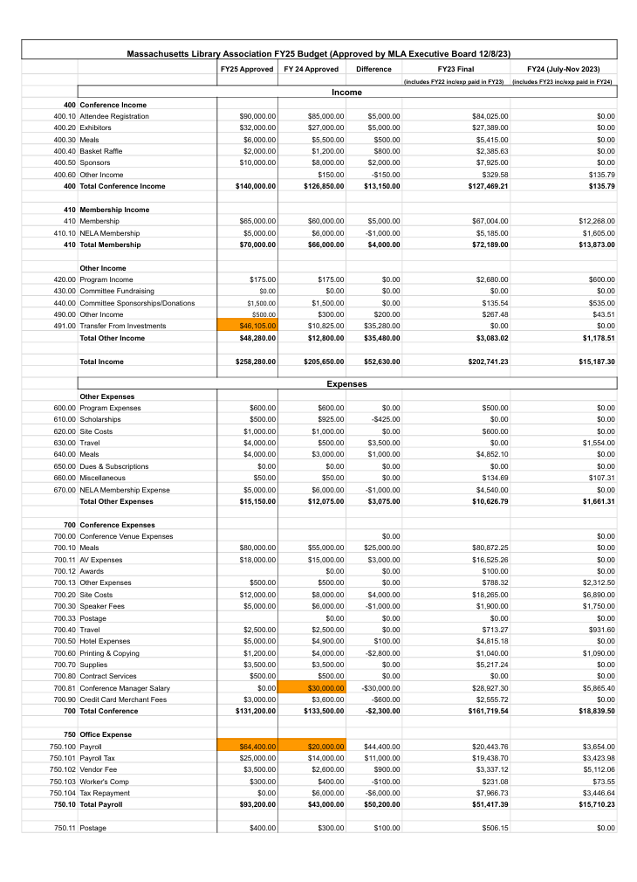
Treasurer’s Report - FY25 Budget - continued

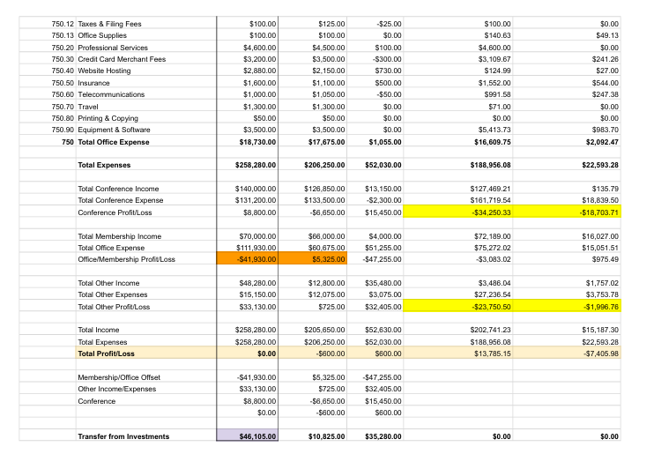

Director of Operations Monthly Activity Report
Name: Kristen Collins
Date: May, 2024

Member Relations | - Managed incoming emails/inquiries/phone calls  - Archived contacts  - Registered attendees for conference and updated membership records
Technical | - Watched online tutorials  - Met with MC Trade and some MLA associates on the website rebuild committee
External Relations | - Prepared NELA report and sent to NELA rep  - Created new members via ALA  - Fielded inquiries from media and/or outside agencies
Conference Management | - 634 registered attendees (sold out)  - 45 exhibitors registered (sold out)  - 7 sponsors  - Attended committee meeting  - Deployed reminder comms to exhibitors, sponsors, attendees  - Managed exhibitor questions  - Prepared a one-sheet for the mayor  - Sent agenda and other printed materials to printer  - Prepared final communications (thank you/survey)  - Gave guarantees/logistical info to hotel and AV provider  - Managed misc details
Finance | - Created numerous group registration invoices for conference
LINKS | MC Trade 13-Min Video:  https://www.youtube.com/watch?v=53lVjcvq4UM&themeRefresh=1  MC Trade Website Templates : https://memberclicks.com/mc-trade-portfolio/

MLA Conference Committee Report 2023

Conference remained a two-day affair on the Cape. We returned to a renovated Seacrest Hotel in Falmouth on May 8-9, 2023. There were 440 registrants, 42 exhibitors, and 13 sponsors. We also sold 5 ads and 1 promo item for insert in the conference swag bag. The theme of the 2023 Conference is “Making Waves,” and programs had a focus on managing the need to shift services and be adaptable after Covid.

Our keynotes for the conference were Tommi Laitio, Bloomberg Fellow, whose session was entitled “Learning Grounds for Conviviality;” ALA President Lessa Kanani’opua Pelayo-Lozada, and PLA President Maria McCauley (Cambridge, MA) who both spoke at the Annual Business Meeting. Michael J. Bobbitt, Executive Director, Mass Cultural Council spoke about riding the wave of change, or, “Why Libraries Must Challenge the Status Quo and Reimagine Their Role in Communities.” We were lucky enough to host David Ferriero, National Archivist, who spoke about the challenges of recording the documentation of the Trump Presidency. Finally, Jonathan Freidman, director of free expression and education programs at the literary and human rights nonprofit PEN America, spoke on “The Evolving Movement to Ban Books and Censor Education.” A truly inspiring line up.

MLA After Dark featured “Silent disco” and Trivia, and held an ongoing Dungeons and Dragons game throughout the conference.

Planning for next year:
The Conference location for 2024 is The Sheraton Framingham, May 6-7. The theme is “The heart of the community.”

Submitted by,
Esme Green, Conference Co-chair

MLA Legislative Committee Report 2023-2024

Legislation
The committee was very active advocating for a number of bills at the State House. These included new and continuing efforts.
- H.3239 ‘eBook Bill’ - The committee attended a hearing and sponsored a briefing to support this Rep. Balser bill. The has garnered widespread support, with over 40 cosponsors. In addition, our committee worked with other stakeholders including Library Futures, and the eBook Study Group. It is currently still in committee.
- H.2447 & S.4235 ‘Freedom to Read’ - These were new bills this year, sponsored by Sen. Oliviera and Rep. Saunders. More than 30 legislators have signed on to support this bill that will protect collections, programs, and buildings for public libraries. These bills have support, but are still in committee.
- H.2449 & S.2528 ‘Freedom to Read’ - Sponsored by Sen. Cyr and Rep. Moran, these companion bills extend protections to both public libraries and school libraries. Our committee worked with members of the ACLU to talk about the bill's language. It is still in committee.

Our committee worked with members of the Library Caucus to host briefings for the first time. We held three briefings, covering eBooks, Freedom to Read, and the MBLC Legislative agenda. This was a good first effort at extending our advocacy reach, we intend to continue this work in the future.

Legislative Breakfasts
After meeting with members of the Library Caucus, the committee decided to put a greater emphasis on legislative breakfasts. The Caucus suggested that it wasn’t a good year for an in person state house event because of lack of legislator attendance. A total of 16 breakfasts with more than 900 total attendees were held during the legislative season. Most parts of the state were covered by this wide range of events. The committee did a better job of tracking stats and details, including pictures, from each event. The committee is gathering feedback from the hosts and held a ‘breakfast debrief’ meeting in the spring. The committee will use this feedback as part of the process for reworking the Breakfast Toolkit and developing a different process for recruiting and supporting hosts.

Outreach
The committee chairs hosted a session for MLA members to offer updates on the library legislation that has been working through this current legislative session. We had great attendance (roughly 60 people) and positive feedback from the people in attendance. We recorded the session and that recording has been made available on the Legislative Committee portion of the MLA website for others to view.

EveryLibrary
The committee continues to work with EveryLibrary on a number of issues. This group has been very supportive of our advocacy efforts. EveryLibrary has provided assistance in the following ways:
- Legislative Support - helping with language and strategy
- Candidate Questionnaire - this is a work in progress, but should go out in the spring
- Coalition Building - EL will host a series of seminars to help committee members build support and coalitions, and to expand our knowledge of advocacy work
- Strategic Thinking - EL partnered with the committee to host discussions about future strategies and projects for our committee

These are the highlights from the work of the Legislative Committee for the past year. This is by no means a comprehensive list, as we had members working on a number of issues and projects throughout the year. The committee continues to be composed of librarians and library advocates from across the Commonwealth and from different types of libraries and library organizations.

Respectfully submitted,

Will Adamczyk, Kathy Lussier, Nora Blake
Cochairs, MLA Legislative Committee

ALA Councilor’s Report

Battling censorship continued to be one of the main focuses of the association this past year. At ALA Annual, there was a resolution that called for ALA’s withdrawal from attending the International Federation of Library Associations and Institutions conference in Dubai. Dubai had stated that if the conference was held there, no programs relating to LGBTQ+ content would be allowed. The resolution passed. IFLA later withdrew its invitation to host the 2024 conference in Dubai. As Dubai was the only viable bid, there will not be a World Library and Information Conference in 2024.

Following the attacks on Gaza, Council passed a resolution on damage and destruction of libraries and other cultural institutions in the region.

At ALA Annual 2023, Council voted on a resolution on maintaining equitable in-person participation for all at ALA Membership meetings. The motion was approved.

The ALA Executive Board approved the request from the ALA Membership Committee to offer a virtual only 2024 Membership Meeting.

A virtual membership meeting was held on January 17, 2024, presided over by ALA President Emily Drabinski. Leslie Burger stepped in as the ALA Interim Director while a search is being conducted for the next ALA Executive Director.

The ALA Committee on Diversity has come together in January 2024 to launch discussion on a multi-year plan for engaging members, ALA Staff, and key partners around EDI initiatives. Ongoing responsibilities discussed by the Committee remain: - The Working Group to Condemn White Supremacy and Fascism - - The Working Group to update the Standards for the Blind and Print Disabled The Working Group to disseminate the Standards for those who are Incarcerated or Detained.

ALA President Emily Drabinski will be taking a tour of American libraries from June 3 - June 22, 2024. The following sites have been confirmed:
Cranston Public Library, Cranston, Rhode Island, RM Captain Elementary School, Clayton, MO, Daniel Boone Regional LIbrary in Columbia, Missouri, the Rossville Public Library in Rossville, Kansas, Page Public Library in Page, Arizona. There will be additional stops in West Virginia and New Mexico. Filmmaker Nikita Carpenter will join the tour to document the great work happening in libraries across the country. The film will be made available to libraries for screening in their communities.

Work continues for the Sustainable Libraries Initiative as they make progress toward a climate agenda for libraries.

Onsite counseling support for library workers will be available at Annual.

Respectfully submitted,
Nanci M. Hill, Chapter Councilor
MLA Intellectual Freedom/Social Responsibility Committee
FY24 Annual Report, May 2024

Summary:
Unfortunately, in FY24 Massachusetts libraries and schools continued to see ever increasing levels of harassment and censorship. IF/SRC reported calendar year 2023 data to ALA’s Office of Intellectual Freedom. We documented forty incidents of harassment, materials, and service challenges- a roughly 35% increase from the data we reported in 2022. MSLA received about half a dozen reports from school libraries in 2023. Many more unreported challenges came to light due to 2023 FOIA requests from a Boston Globe reporter who queried all MA school districts as well as an individual who queried both school and public libraries. We look forward to MBLC’s new ARIS IF questions to help provide a more accurate data set.
Fortunately, throughout the crisis Massachusetts libraries marshaled our many strengths. MLA continued to work with MSLA, MLS, and MBLC on the Intellectual Freedom Task Force to ensure libraries are informed and supported. The Massachusetts Legislature came through with multiple freedom to read bills as the result of previous years advocacy and education efforts. IF/SRC worked with the Legislative Committee, MBLC, MSLA, and EveryLibrary to guide lawmakers in strengthening the bills to best protect readers, students, and library workers.
In our committee’s effort to educate and advocate we have been in demand to speak to dozens of libraries, public forums, colleges, faith groups and so many media outlets.
After two years as Co-Chair of the IF/SRC, Susan Caulfield is stepping down, but will remain on the committee as an Intellectual Freedom Champion. We are grateful for her leadership and expertise.
A few highlights of this year’s work include:
- Worked with MBLC, libraries throughout the state, and media to launch Read-Ins and other events to draw attention to censorship during Banned Book Week--77 libraries throughout the Commonwealth participated in our polite protests. Media coverage was robust, including television, radio, and newspapers.
- Advocated, briefed and testified on behalf of freedom to read bills S.2528 & H.4229, S2447, and H4005 at the statehouse, consulted with MSLA on their testimony as well as rallied others to testify, write letters of support and show up for hearings.
- Helped begin a partnership with The Sustainable Library Initiative which gives MLA member libraries a discount for sustainability certification and free on demand professional development
- Wrote a statement of support for the MA Trans-Librarians advocacy group

- Continued member of the IF Task Force along with MLS, MLA, MSLA, and MBLC representatives
- Committee members spoke throughout the state on the current climate of censorship and harassment. A (very partial) list includes: Regis College, Tufts Osher Lifelong Learning Institute, Central Mass Library Advocates, League of Women Voters, Newton Free Library, and Hamilton-Wenham Human Rights Coalition.
- Andrea Fiorillo was a guest lecturer for Simmons University LIS Intellectual Freedom
- Consulting on challenges and harassment throughout the state
- Interviews and research assistance for multiple media outlets--highlights include The Washington Post, National Public Radio, and Chronicle from WCVB Channel 5.
- Continued data collection for challenges in Massachusetts
- Attended the Public Library Association Conference and networked with EveryLibrary and ALA OIF, and Unite Against Book Bans staff
- Andrea Fiorillo was selected, along with two licensed school library teachers, to be trained by ALA in a Law for Librarians intensive in Chicago. The aim is for trainees to then be able to consult on issues surrounding the First Amendment, CIPA, social media and the internet, privacy & confidentiality, youth and the law & school librarians copyright
- Recruiting new members
- Planning and implementing conference sessions
IF/SRC is sponsoring and facilitating these conference sessions:

Generative AI and Bad Actors: How Libraries Can Address AI-Created Disinformation

Leading with Love: Celebrating Pride at Your Library

Banned in the USA: A History of Censorship, Book Bans, and First Amendment Freedoms

Our Grandest Challenge with The Sustainable Libraries Initiative Keynote

Fired for Freedom: Lessons from the Front Lines Keynote

The Impact of Anti LGBTQ+ Challenges to Youth Collections, Services, and Staff
- It's Called Praxis: How Cis Managers Can Do Better & Why They Should Start Now

Committee Roles:
- Chair: Andrea Fiorillo
- Massachusetts School Library Association Liaison: Laura Harrington
- Conference Committee Liaison: Clayton Cheever
- Intellectual Freedom Champion: Matt Amory, Susan Caulfield
- Legislative Committee Liaison: William Adamczyk
- MBLC Liaison: Cate Merlin
- MLS Liaisons: Michelle Eberle and Jane Stimpson
- Secretary: Annette Diola
- Social Planner: Annette Diola

Respectfully submitted,
Andrea Fiorillo

Personnel Issues and Education Committee (PIE) Annual Report
May 2024

The Committee had collected a group of resources from participating MLA members in regards to alternate places to post open library positions beyond just the MBLC jobs page that might increase accessibility to a wider range of candidates. Those resources are posted on the MLA website under the Personnel & Education link.

The Committee has also posted on the website some activities and parameters for interns and/or volunteers at libraries.

PIE has been interested in starting a mentorship program for MLA, separate from the one that NELA hosts. With the reinvigoration of the Leadership and Management Section, PIE has engaged in talks with them about creating a mentorship program and hope to be able to have one in place in the coming year.

It is our estimation that Leadership and Management includes almost everything that Personnel and Education also does, so it only makes sense for PIE to cease as a separate group and instead become part of what Leadership and Management already brings to the table. It has been more difficult sustaining interest in the Personnel Issues and Education Committee, while LAMS has more momentum and a wider range. We will move forward with merging the two sections to better serve the MLA community.

Respectfully submitted,
Noelle Boc
Chair

Jordan Miller Committee Annual Report
May 1, 2024

The Jordan Miller Committee reviewed 23 applications for the
$500 Jordan Miller mini grant and chose the Middleborough Public Library in Middleborough, MA.

The Middleborough Public Library used the funds to host Haitian Creole Storyteller Charlot Lucien at a storytelling event on Feb. 21st 2024.
The event was successful, with a good attendance at 40 people.

Children’s Librarian Amanda Meyer ran the event. Here is an
excerpt from her report:

“On Wednesday, February 21st, 2024 we hosted storyteller Charlot Lucien to a crowd of 40 at the Middleborough Public Library. Migrant families currently residing at the Quality Inn in Middleborough were offered a school bus ride to the Library in order to participate in the
program. Most audience members spoke Haitian Creole, but some spoke Spanish and others English. Charlot did an exceptional job of communicating with everyone who attended in a fun and engaging way. Families, especially those from Haiti, were moved by his interactive performance, laughing and smiling throughout. His riddles and stories clearly resonated with the adults. Everyone learned about Haitian culture and history…The Library had a table of materials in multiple languages.”

Preference this award year was given to Massachusetts Libraries. In 2024, preference will be given to New England Libraries outside of Massachusetts.
The award was announced on MASSYAC and through the NERTCL state representatives last December.
Amy Dorsheimer of the Nevins Public Library and Pam McCuen of the Wayland Free Public Library served on the committee this year.
Respectfully submitted,

Amy Dorsheimer and Pam McCuen
Jordan Miller Committee Co-Chairs

Membership Report

As of May 1, 2024 the Massachusetts Library Association has 769 Members, which includes all categories, personal and institutional.

In 2024 a Membership Working Group was formed to analyze the dues structure. Dues had not been raised since 2018, and the Executive Board asked that there be a review of the dues structure in the light of fiscal concerns and changes in the economy. A working group was formed, which included the President, Vice-President, Past President, Treasurers, the Association Executive and the Membership Chair. A new proposal was crafted, which abbreviated the number of categories of personal membership, and moved to an income-focused assessment only. Institutional memberships were reviewed and it was decided to pilot a dues structure that mirrored the personal membership scale, and was dependent on operating budget. The attached proposal was developed to be presented at the Annual Meeting of the Association on May 7th, 2024.

In anticipation of a membership campaign to be conducted in FY25, a new brochure for membership recruitment was designed and printed. The Membership Committee is seeking more volunteers to help with the membership campaign!

Respectfully Submitted,
Krista I. McLeod,
Membership Chair

Proposal for Updating Dues for Annual Meeting May 7, 2024
Massachusetts Library Association
Proposed by Membership Working Group

Background/Explanation:
The Association has not changed its Dues structure or increased its member rates since 2018. During the pandemic, the cancellation and scaling back of conferences and other income sources for Association has created a need to review all income sources. As the Association is now in a position to grow its programs and services for members, it is time to review dues so that they more accurately reflect the base cost of serving members with the educational, advocacy and informational resources they need and want. Attached is a chart of the proposed changes in both the structure of dues and the member rates. This proposal streamlines the categories and decreases the number of possible member types to focus on income/budget as the primary classification criteria for membership. An attempt was made to keep member rate increases as modest as possible, but this proposal also acknowledges the length of time since the last increase and reflects inflation.

This proposal will be on the Agenda of the MLA Annual Meeting, which will be held at 8am on Tuesday May 7, 2024 at the Sheraton Framingham Hotel & Conference Center. The new dues and rates structure would go into effect on July 1,2024. ALA Student Member rates would not change, since that is an ALA program that the Association participates in. NELA rates would not change for the same reason.

Organizational members include libraries, Friends groups, other professional organizations and associations.

This proposal has been developed by a working group of MLA leadership:
Michelle Filleul, President; Noelle Boc, Vice-President; Sarah Breen, Treasurer; Bernadette Rivard, Past Treasurer; Danielle Savin, Assistant Treasurer; Krista McLeod, Membership Chair; Kristen Collins, Director of Operations

Proposed Dues Structure & Rates to be effective July 1, 2024
Category | Proposed Annual Rate
Personal Member--Income up to $39,999 | $50
Personal Member—Income $40,000 to $79,999 | $100
Personal Member—Income $80,000 to $99,999 | $150
Personal Member—Income $100,000 and above | $200
Organizational Member Silver—Budget* up to $499,999 | $500
Organizational Member Gold—Budget* $500,000 to $1M | $1,000
Organizational Member Platinum – Budget* over $1M | $1,500
*Based on Operating Budget
Other Dues
NELA Membership Add-on | $20
ALA-MLA Joint Student Membership – paid to ALA | $43

Updated Benefits for Institutional Members
- Institutional Members can send as many staff as they wish to Conferences and Programs and pay the Member Rates for all
- Vendor Discounts will be negotiated to include Institutional Members – check our new website for upcoming deals
- Each level of Institutional Member gets Voting Memberships as part of their package
  - Silver Members – 2 Voting Memberships
  - Gold Members – 4 Voting Memberships
  - Platinum Members – 6 Voting Memberships
- Your organization will be acknowledged as an Institutional Member on our NEW MLA Website!
New Dues
If passed at the 2024 Annual Meeting, our new dues structure will go into effect as of July 1st, 2024. However, any membership paid prior to that time will not be charged under the new dues rate until their anniversary-based renewal in 2024 or 2025.
For Comparison:
2018 Dues Structure and Rates
Under 19K $20.00
20 - 29K $50.00
30 - 40K $75.00
40 -50K $90.00
50 - 60K $100.00
Over 60K $125.00
Over 80K $140.00
Retirees $20.00
Student/Unemployed $20.00
Sustaining $200.00
Trustees/Friends $20.00
Institutional Silver category {eliminated)
Institutional Gold $600.00
Institutional Platinum $1,000.00
Revised 4/27/24

