MLA Reference and User Services Section Meeting Minutes
Needham Free Public Library
August 23, 2019 10 AM-12 PM

Discussion on Library Fines
We had three perspectives for our discussion of Library Fines. Becca Lemos (Newburyport) shared her experience working at a fine free library. Sarah Breen (Needham) talked about reasons why her library has kept fines and our guest Clayton Cheever (Quincy) discussed his library’s transition to being fine free for children and teens.

Points in Favor of No Fines:
-many libraries do not receive the funds collected from fines
-creates a negative experience for patrons and staff which can cause:
-staff burnout
-decreased library use/circulation of materials
-loss of physical items
-creates goodwill in the community which can lead to:
-increased library use/circulation of materials
-willingness to support funding for large projects (especially renovations)
-gifts/donations to library
-return of physical materials
-reduces barrier to access for low income patrons
-studies show that fines don’t encourage responsibility/ it isn’t our role to be enforcing
-enforcement of fine policy can be erratic and inflexible

Points Against Elimination of Fines
-fine money is a source of revenue for the library
-political and municipal pushback
-responsibility to make sure shared items are available to all
-confusing to patrons and other libraries in shared network

Elimination of fines can be done gradually to minimize the financial repercussions. Many libraries begin with amnesty periods (day, week, month or even a season). Libraries that are open during renovations or construction will waive fees due to the difficulty of getting to the building. Another strategy is to reduce the actual cost of fines, especially on popular items such as DVDs. Some libraries have eliminated fines on Large Print materials and books by mail/homebound services so that seniors with mobility issues have easier access. Raising the dollar threshold for blocking accounts has helped increase circulation and return of items. One library (Winchester) waive fines for anyone who signed-up for summer reading this year. Circulating technology items and Library of Things items are usually the exception to fine free, due to the cost burden on the library.

In regards to blocked cards, most libraries have done away with blocks on public computers for patrons with fines. It is a huge barrier to access and it further increases inequality among patrons. Another point mentioned was libraries that allowed children/teens to “read away” the fines on their accounts. This isn’t a good option because it excludes those who have reading limitations and well as transportation to the library. One of the big reasons many public libraries begin their fine elimination with children/teen items is because of transportation. Children rely on others to get them to the library and it isn’t fair to punish them.

Slowly eliminating fines helps to create a positive culture, and rebuild relationships within the community. Patrons still need to be held accountable and many are through overdue notifications, billing and collections. Changing renewal (automatic options) and loan policies can also help eliminate the frequency of fines. It is important to be mindful of neighboring libraries, their policies and how any change in your library can create confusion among patrons and staff. If you are a library that sees a lot of patron overlap with another community, it is important to bring them into the conversation. Overall it is important to have compassion and flexibility. Libraries are supposed to be free for all and steps towards fine elimination helps to break down financial barriers to access.

Resources:

ALA “Resolution on Monetary Library Fines as a Form of Social Inequality”

Colorado Department of Education “Removing Barriers to Access: Eliminating Fines and Fees on Children’s Materials”

American Libraries, “An Overdue Discussion”, June 2018

Fine Free Map

Library Journal, “Doing Fine(s)? Fines and Fees”

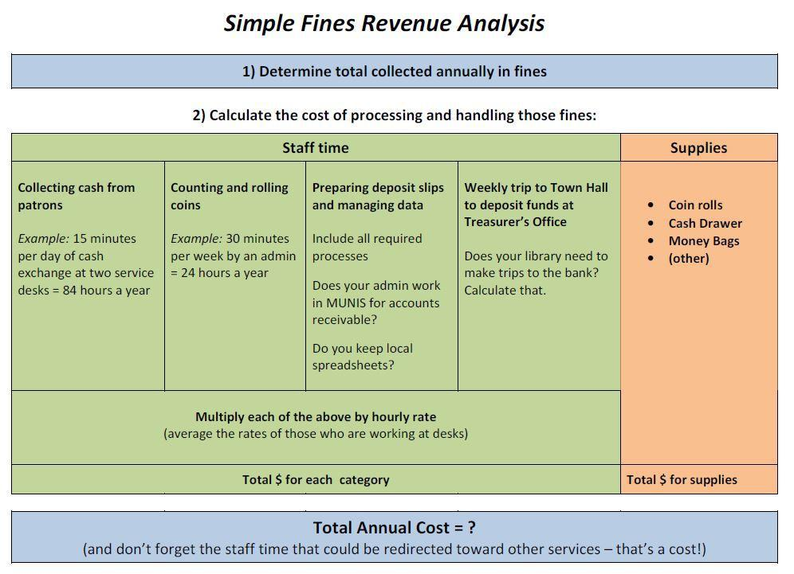
Simple Fines Review Analysis From the Ipswich Public Library below:

